Use-Case Realization Report
Create Error

Issue <1.0>
Revision History
Date | Issue | Description | Author
<29/apr/11> | <1.0> | Initial Document | Koh Ming Jin

Table of Contents
1. Brief Description 4
2. Flow of Events 4
2.1 Standard Flow 4
2.2 Exception 4
3. Interaction Diagrams 4
3.1 Collaboration Diagram for Create Error 4
4. Participating Objects 4
4.1 Error 4
4.2 Create Error Screen 4
5. Class Diagrams 5
5.1 Domain Class Diagram: Create Error 5
6. Derived Requirements 5

Use-Case Realization Report
Create Error

Brief Description
This use case enables an operation manager to create a new error record. The required information includes the error ID, error name and error explanation.

Flow of Events
The standard flow of events for this use case and any exceptions are described in the following subsections. See section 3.1 for an overview of the participating Actors and Domain Objects.

Standard Flow
The flow of events is described as follows:

- The use case starts when Operation Manager selects the Create Error option of the system.
- The Create Error Screen is displayed.
- The Operation Manager provides all the required details concerning a new error into the Create Error Screen.
- The existence of the new error in the system is checked against the error information held by the database.
- If the new error is not existent, the error record is created with the supplied details.
- The use case terminates.

Exception
- New error already existed. If the new error is found to be an existing one, the error creation fails. An error message is displayed, and the Create Error Screen is displayed again.

Interaction Diagrams

Collaboration Diagram for Create Error
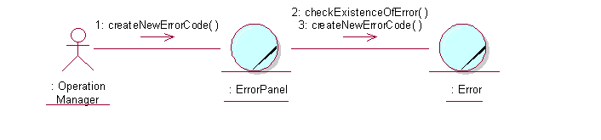

Participating Objects

Error
This object stores the details concerning the error of the COMS.

Create Error Screen
This screen is used for collection of error details, when a new error record is to be created. The Director, Department Manager and Operation Manager actors use this object.

Class Diagrams

Domain Class Diagram: Create Error
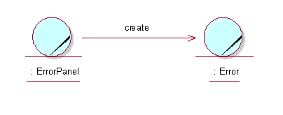

Derived Requirements
The Operation Manager PC keyboard and mouse will be used to enter error details (if any) and view all the system responses.

